Introduction

For this assignment I am analyzing the financial records of a company by creating a Python script. The given set of financial data is quite simple. The dataset is composed of two columns: Date and Profit/Losses

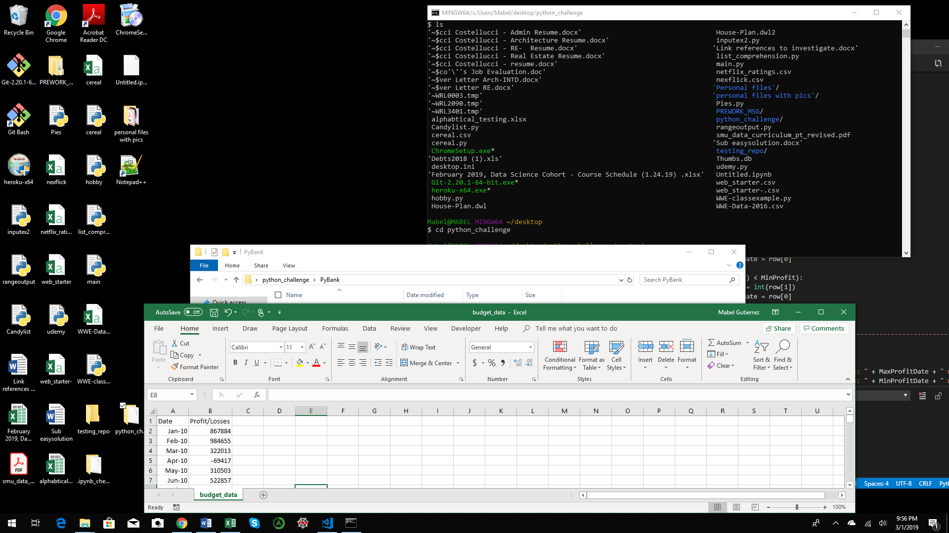

To start analyzing the records using Python, I imported the os and csv modules. Then I set the path for the given dataset called budget_data.csv. Next, variables were created and initialized. Afterward, using the csv module a reader variable was created with the “,” being set as my delimiter. After that, another code was made to read and print out the header. Next, a for loop was created to start reading each row of data after the header. Then, formulas were created to calculate the total number of months, the total net amount, and averages. To look for the minimum and maximum value an if statement was used. And last but least, a print function was used to show all the outputs.

This project has been uploaded to the GitHub repo called python_challenge and the corresponding file is PyBank. The file name “main.py” is where the Python script resides to run the analysis.

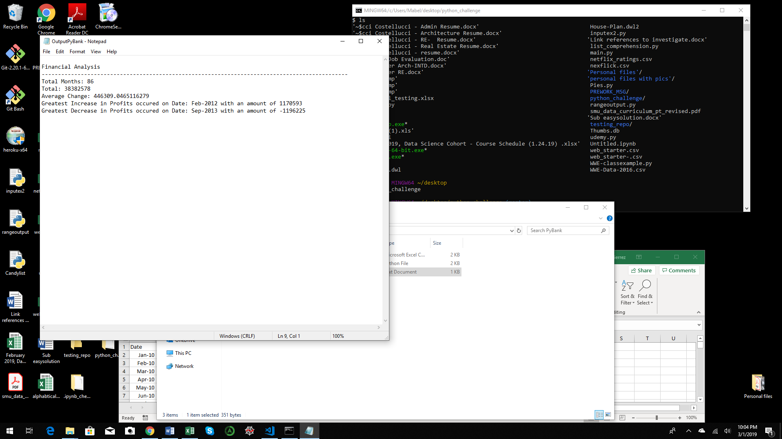

Results

The results show that the given financial data set included a total of 86 months.

The net total amount of “Profit/Losses” over the entire period was $38,382,578

The averages of the changes in “Profit/Losses” over the entire period was $446,309.05.

The greatest increase in profits over the entire period happened in February of 2012 for $1,170,593.

The greatest decrease in losses over the entire period happened in September of 2013 for $1,196,225.

Just by looking at the number it shows that most projects will pick up sometime around the 3rd quarter since this is where most of the spending happens but, the returns of investments is mostly captured during the first quarter.